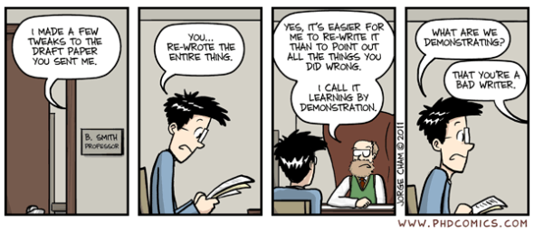

I made a few tweaks to the draft paper you sent

You re-wrote the entire thing

Yes, it’s easier for me to re-write it than to point out all the things you did wrong

I call it learning by demonstration

What are we demonstrating

That you’re a bad writer

Bagaimana tanggapan anda terkait fenomena pada gambar diatas?

Bagaimana tindakan yang ideal bagi seorang penulis ilmiah?